***Travel King***

* **Why PUBLIC TRANSPORT BUSES ?**

1. Comprehensive and affordable way of transport.
2. Reduce fuel consumption and pollution and also curb traffic congestion.

* **DEMAND OF USERS**

1. Accurate arrival time of buses.

2. Avoiding Long time waiting at bus stop.

3. Real Time Travel tracking upto destination.

* **DIFFICULTY FACED BY PASSENGERS**

1. Passengers may not have complete information about these buses.
2. Like number of buses that go to the required destination.
3. Bus numbers.
4. Bus timings.
5. Routes through which the bus would pass.
6. Time taken for the bus to reach.

* **OUR IDEA**

1. Our proposed system is an Android based application that gives a platform to the users to check the real time location of buses running on any route.

2.Our proposed system also developes a second android application for transportation authority by which they can easily resolve monitor the buses by sitting in control room.

3.Our proposed solution also is to create a cloud server which will be used to fetch database online.

4. Also, Android is a user friendly platform, thereby enabling ease of access for all the users. A number of applications made for the Android Operating System is increasing on a large scale ever since its advent. Android is an open source mobile software environment.

5.Gps tracking modules would be installed in state government busses which would be connected through raspberry pi.

**PURPOSE:**

1. The main goal of the proposed work is to improve the Bus system by adding the necessary additional features into the application like
2. accurate bus timings,
3. correct bus numbers
4. and moreover adding a GPS tracker into it
5. This study accepts input in the form of selection of the source and destination and selection of the bus travelling the distance to display the entire details about the routes and also track the location of the respective bus and give the map for the same.
6. .the system will use driver side application, client side application and server.
7. Purpose is to build application that will help students, to access current

DATA ANALYSIS

|  |  |  |  |  |  |  |
| --- | --- | --- | --- | --- | --- | --- |
| NUMBER OF BUSES | | : | 4500 |  |  |  |
|  |  |  |  |  |  |  |
| NUMBER OF BUS DEPOT IN RAJASTHAN: | |  | 56 |  |  |  |
|  |  |  |  |  |  |  |
| NUMBER F DEPOT OUT SIDE RAJASTHAN | | : | 3 | (DELHI,INDORE,AHEMDABAD) | | |  |
|  |  |  |  |  |  |  |  |
| NUMBER OF ROUTE ON DAILY BASIS | |  | 2044 |  |  |  |  |
|  |  |  |  |  |  |  |  |
| NUMBER OF NIGHT SERVICES BUSES | |  | 1083 |  |  |  |  |
|  |  |  |  |  |  |  |  |
| NUMBER OF KM PER DAY | KM/DAY |  | 16 LAKH |  |  |  |  |
|  |  |  |  |  |  |  |  |
| TOTAL NO OF STAFF | |  | 23251 |  |  |  |  |
|  |  |  |  |  |  |  |  |
| PASSENGER/DAY | |  | 950000 |  |  |  |  |
|  |  |  |  |  |  |  |  |

**GPS Tracking Unit**

A GPS tracking unit is a device, normally carried by a moving vehicle or person, that uses the Global Positioning System to determine and track its precise location, and hence that of its carrier, at intervals. The recorded location data can be stored within the tracking unit, or it may be transmitted to a central location data base, or Internet-connected computer, using a cellular (GPRS or SMS), radio, or satellite modem embedded in the unit. This allows the asset's location to be displayed against a map backdrop either in real time or when analyzing the track later, using GPS tracking software. Data tracking software is available for smartphones with GPS capability.

**SQLite Database**

SQLite is a relational database management system contained in a C programming library. In contrast to many other database management systems, SQLite is not a client– server database engine. Rather, it is embedded into the end program.SQLite is ACID-compliant and implements most of the SQL standard, using a dynamically and weakly typed SQL syntax that does not guarantee the domain integrity.SQLite is a popular choice as embedded database software for local/client storage in application software such as web browsers. It is arguably the most widely deployed database engine, as it is used today by several widespread browsers, operating.

**Android**

Android is a mobile operating system (OS) currently developed by Google, based on the Linux kernel and designed primarily for touchscreen mobile devices such as smartphones and tablets. Android's user interface is mainly based on direct manipulation, using touch gestures that loosely correspond to real-world actions, such as swiping, tapping and pinching, to manipulate on-screen objects, along with a virtual keyboard for text input. In addition to touchscreen devices, Google has further developed Android TV for televisions, Android Auto for cars, and Android Wear for wrist watches, each with a specialized user interface. Variants of Android are also used on notebooks, game consoles, digital cameras, and other electronics. Now we have phones which can even access GPS, GPRS, Wi-Fi, NFC and lot of other cool and advanced features which you cannot even imagine. So in this Mobile world of this complication.

**Hardware Requirements**

|  |  |  |  |
| --- | --- | --- | --- |
|  | System Processor | : | Pentium P4 |
|  | Mobile Processor | : | 1GHz or higher |
|  | Motherboard | : | Genuine Intel |
|  | RAM | : | 1 GB or higher |
|  | Memory | : | 200 MB or higher |

**Software Requirements:**

|  |  |  |  |
| --- | --- | --- | --- |
|  | Operating system | : | Windows XP |
|  | Technology Used | : | Android 4.1 or higher |
|  | IDE | : | Android Studio |
|  | Emulators | : | Micro emulator 555 |
|  | Plug-in | : | ADT plug-in |
|  | Back-End | : | php, SQLite |

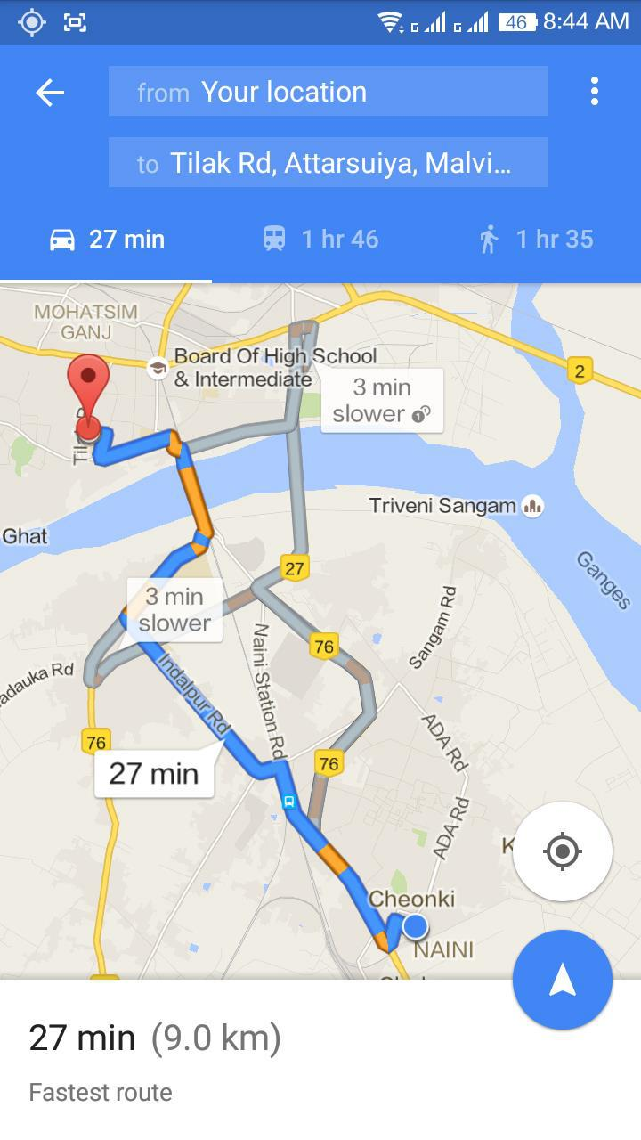

Snapshots